Westside Wellness Center

Name____________________________________________________ DOB: ___________________
Social Security or Medicare # ______________________________________________
Home Address_____________________________City_______________Zip__________
Cell Phone__________________________Cellular Service Provider_______________
Email address____________________________________________________________
Emergency Contact & Phone_______________________________________________
When did your current complaints start?____________________________________
In what extremities did they start first?_________________________________
Did your symptoms start slowly or all at once?____________________________
What testing has already been done? [ ] Bloodwork [ ] MRI [ ] Nerve Tests [ ] Biopsy
Please bring all of them with you to your initial evaluation.

Please mark all areas for pain (P) or numbness (N)

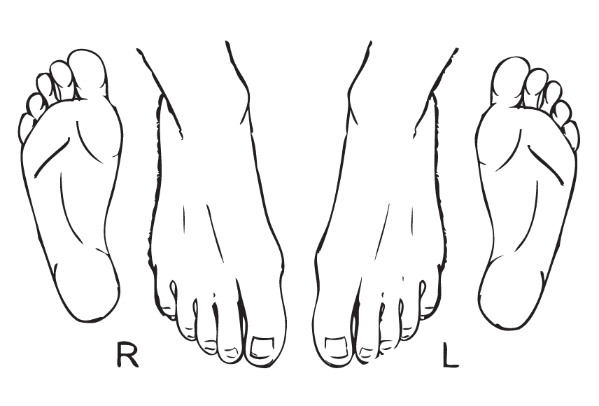
Peripheral Neuropathy Questionnaire

Name:_________________________________________ Date _______________
Please take a few minutes to answer the following questions about the feeling in your legs and feet. Check yes or no based on how you usually feel. Thank you

1. Do you ever have legs or feet that feel numb? □ Yes □ No

2. Do you have burning pain in your legs and/or feet? □ Yes □ No

3. Are your feet too sensitive to touch? □ Yes □ No

4. Muscle cramps in your legs and feet especially at night? □ Yes □ No

5. Do you have prickling or tingling feelings in your legs or feet? □ Yes □ No

6. Does it hurt at night or when the covers touch your skin? □ Yes □ No

7. When you get into the tub or shower, are you unable to
tell the hot water from the cold water with your feet? □ Yes □ No

8. Do you get sharp, stabbing pain in your feet or legs? □ Yes □ No

9. Do you feel weak when you walk? □ Yes □ No

10. Are your symptoms always worse at night? □ Yes □ No

11. Do your legs and/or feet hurt when you walk? □ Yes □ No

12. Are you unable to sense your feet when you walk? □ Yes □ No

13. Is the skin on your feet so dry that it cracks open? □ Yes □ No

14. Is your balance noticeably different than it used to be? □ Yes □ No

15. Do you trip on rugs? □ Yes □ No

16. Do you have difficulty going upstairs? □ Yes □ No

17. Are there any positions that relieve or make your pain worse?  □ Yes □ No
If yes please describe._______________________________________________

18.Have you ever had a head injury? □ Yes □ No

19. Has your handwriting changed in recent years? □ Yes □ No

20. Have you noticed clumsiness in your hand coordination? □ Yes □ No

21. Do you have difficulty getting or staying asleep? □ Yes □ No

22. Do you have decreased or increased urination? □ Yes □ No

23. Do you find yourself searching for words? □ Yes □ No

24. Do you have a hard time with math problems? □ Yes □ No

25. Have you had any dental infections, root canals or extractions? □ Yes □ No

26. Do you spend more than two minutes on the toilet? □ Yes □ No

27. Are some of your family members diabetic? □ Yes □ No

28. Do you wake at night to urinate? Is it from 1-3AM? □ Yes □ No

29. Do you experience water retention? □ Yes □ No

30. Do you have acid reflux? □ Yes □ No

31. Do you Fatty Liver Disease? □ Yes □ No

68 DRUGS THAT CAUSE NEUROPATHY

The most common drug induced neuropathy is from Statin drugs used as cholesterol medication. Please refer to the list below of the 68 known drugs that cause Neuropathy.
If you have been using any of these meds please CIRCLE them and let the doctor know. We highlighted the most common ones for your ease of selection.

Allopurinol, Almitrine bismyslate, Amiodarone, Amitriptyline, Ara-C, Aspartame, Bortezomib, Carbamide, Chemotherapy agents (17) Bortezomib, Oxalipatin, Taxanes,Thalidomide, Vinca alkaloids, Chloramphenicol, Chloroquine, Chlorprothixene, Clioquinol, Clofibrate, Colchicine, Cipro, Cyanate, Cyclosporine, Danosine, Dapsone, Dichloacetate, Disopyramide, Disulfiram, Docetaxel, Enalapril, Ethambutol, Ethionamide, Etoposide, Glutethimide, Gold, Hydrazaline, Imipramine (tricyclic anti-depressants), Isoniazide, Lasinipril, Leflunomide, Levaquin, Lithium, Metformin, Mercury, Methaqualone, Metronidazole, Nitrofurantoin, Nitrous Oxide, Paclitaxel, Phenelzine, Phenytoin, Proton Pump Inhibitors (Aciphex, Protonix, Prevacid,
Prilosec), Propafenone, Pyridoxine, Statins, Stavudine, Sulfasalazine, Suramin, Tacrolimus, Thalidomide, Tumor Blockers, Vancomycin, Vincristine, Vinorelbine, Zalcitabine.
Please let us know if you are taking any of the following blood thinners: Rivaroxaban (Xarelto)
Dabigatran (Pradaxa), Apixaban (Eliquis), Heparin (various), Warfarin (Coumadin) OR aspirin.

Please let us know if you are on any of the following blood thinners: Rivaroxaban (Xarelto)
Dabigatran (Pradaxa), Apixaban (Eliquis), Heparin (various), Warfarin (Coumadin), OR aspirin.

Toxicity Symptoms & Dietary Questionnaire

INFORMED CONSENT: NEUROPATHY PROGRAM

PATIENT NAME: ___________________________________________________________________

Initial Analysis / Examination

As a part of the analysis and examination process, you are consenting to the following procedures: Postural analysis and balance testing, range of motion, palpation, neurological testing, muscle strength testing and orthopedic testing.

Treatment: The nature of our Kinesiology & Chiropractic treatments.

All of the treatments utilized in the neuropathy treatment program are considered non-manipulative. They are completely safe and although Dr. Kelberman is licensed as a chiropractor he will “NOT” be using traditional spinal manipulation therapy. These non manipulative treatments include: Craniosacral therapy, very gentle non painful mechanical instruments applied in a way as to move your joints specially designed by Dr. Kelberman for your feet, muscle tissue work, lymphatic release, strengthening and stretching. Sometimes, manual manipulation is a better choice for you. If you wish to have manipulation, please tell your practitioner at the beginning of your session and initial here _____________.

Class IV Laser Therapy Precautions: Laser therapy is a very safe therapy. We protect ALL eyes with special goggles. You may never look directly into the laser beam even with the goggles. It will cause blindness. The therapist is well aware of this issue and will take ALL necessary precautions to protect you and the therapist.

Please let us know if you are pregnant, taking blood thinning medication, have active cancer, a pacemaker or defibrillator.

The availability and nature of other treatment options.

Other treatment options for your condition may include: Self-administered, over-the-counter analgesics and rest. Medical care and prescription drugs such as Lyrica, Gabapentin, Norco, anti-inflammatory, muscle relaxants and pain-killers, Intravenous Gama globulin infusions, hospitalization, injections or surgery.

DO NOT SIGN UNTIL YOU HAVE READ AND UNDERSTAND THE ABOVE.

I have read or have had read to me the above explanation of the various treatments that are part of my care. I have discussed them with Dr. Kelberman and have had my questions answered to my satisfaction. By signing below I state that I have weighed the risks involved in undergoing examinations and treatment. I have decided that it is in my best interest to undergo the treatment recommended. Having been informed of the risks, I hereby give my consent to that treatment. I realize that the practice of medicine and chiropractic is not an exact science and I acknowledge that no guarantee has been made to me regarding the outcome of these procedures. I have received a copy of this consent.

No information regarding our patients is shared or distributed with any other person or organization without the patient’s signed authorization. Your signature below acknowledges receipt of our privacy policy information statement.

Dated:___________Patient’s Signature_____________________________

Dr. Jason Kelberman, DC, BCIM__________________________________________

